**DAILY ONLINE ACTIVITIES SUMMARY**

|  |  |  |  |  |  |  |  |  |
| --- | --- | --- | --- | --- | --- | --- | --- | --- |
| **Date:** | **18/5/2020** | | | | | **Name:** | **Nivedita** | |
| **Sem & Sec** | **2nd year/4th sem/A-section** | | | | | **USN:** | **4al10cs053** | |
| **Online Test Summary** | | | | | | | | |
| **Subject** | | **Complex analysis,probability and staticall methods (18MAT41)** | | | | | | |
| **Max. Marks** | | **30** | | **Score** | | | **Not yet** | |
| **Certification Course Summary** | | | | | | | | |
| **Course** | **Deep learning** | | | | | | | |
| **Certificate Provider** | | | **yes** | | **Duration** | | | **2 hours** |
| **Coding Challenges** | | | | | | | | |
| **Problem Statement1: An Anagram of a string is another string that contains same characters, only the order of characters can be different.**  **For example, "act" and "cat" are anagram of each other** | | | | | | | | |
| **Problem statement 2;Given an array of distinct integers. The task is to count all the triplets such that sum of two elements equals the third element.** | | | | | | | | |
| **Uploaded the report in Github** | | | | | **yes** | | | |
| **If yes Repository name** | | | | | <https://github.com/nivi-nivedita/lockdown-coding-program> | | | |
| **Uploaded the report in slack** | | | | | **yes** | | | |

Online Test Details: online test conducted at 9:30 to 10:00am.which included 30 questions and 1 mark each.

Certification Course Details: I started course as deep learning. And I completed it in 2 hours. Deep learning is an [artificial intelligence](https://www.investopedia.com/terms/a/artificial-intelligence-ai.asp) function that imitates the workings of the human brain in processing data and creating patterns for use in decision making. 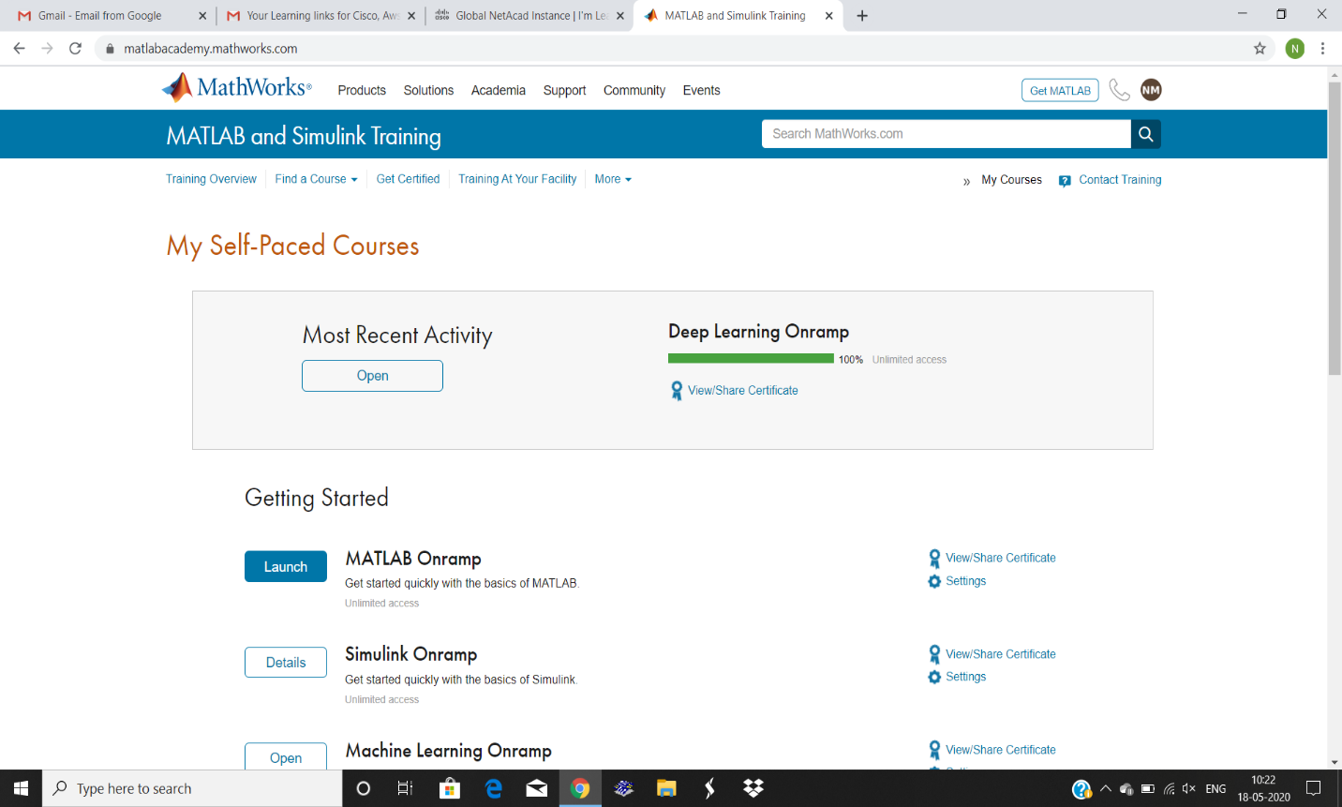

Course certificate;

Coding Challenges Details: we got challenges.

1 .Anagram program uploaded to github.

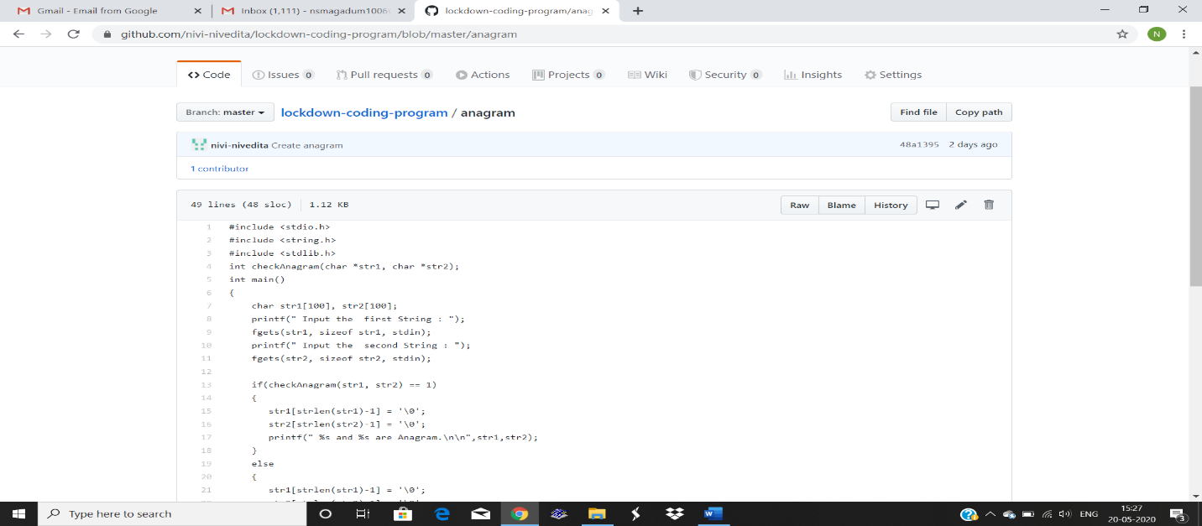

2 . Given an array of distinct integers. The task is to count all the triplets such that sum of two elements equals the third element.



  
  
  
    